**FILE PERMISSONS**

**LINUX DAY 6**

* **Read: Permission to read the file content read - 4**
* **Write: Permission to modify the content -2**
* **Execute: Permission to run the script -1**

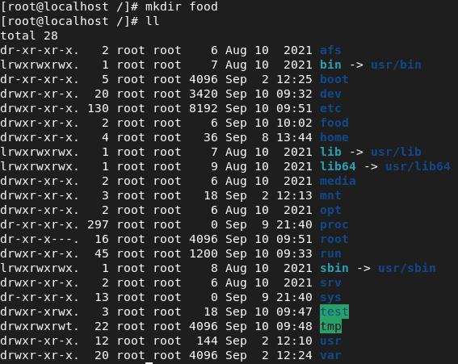

* d | rwx | r-x | r-x

d 🡪 directory

rwx 🡪 user

r-x 🡪 group

r-x 🡪 others

r 🡪 read (4)

w 🡪 Write (2)

x 🡪 Execute (1)

**CHMOD: CHANGE MODE**

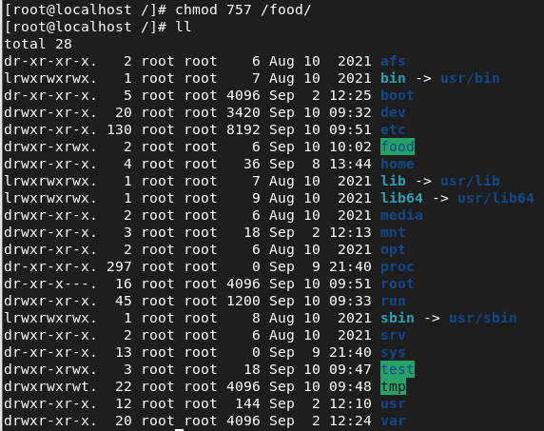

**UMASK 022:**



|  |  |
| --- | --- |
| **NORMAL PERMISSIONS:** | **FULL PERMISSIONS:** |
| Directory 🡪 755 | Directory 🡪 777 - 022 |
| File 🡪 644 | File 🡪 666 - 022 |